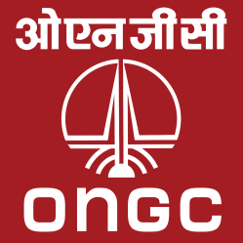

**ONGC SUMMER TRAINING**

**PROJECT REPORT**

**2015**

**Prepared By-**

**Ashish Kumar Singh**

**LNM Institute of Information**

**Technology, Jaipur**

**Electronics & Communication Engineering,**

**2nd year Undergraduate**

ACKNOWLEDGEMENT

I WOULD LIKE TO GIVE MY HEARTIEST GRATITUDE TOWARDS ONGC FOR ALLOWING ME FOR SUMMER TRAINING FOR THE SUMMER 2015.

I WOULD LIKE TO EXTEND A DEEP SENSE OF GRATITUDE TO **SHRI. PRIYANKAR NAINWAL**, DGM E&T FOR PROVIDING NECESSARY FACILITY AND INFRASTRUCTURE FOR MY SUMMER TRAINING PROJECT.

I ALSO LIKE TO THANK **SHRI. MANJEET SINGH**, DEPUTY S.E. E & T, MY GUIDE AND IN CHARGE, FOR HIS ENCOURAGEMENT AND GUIDANCE WITHOUT WHICH MY TRAINING WOULD NOT HAVE BEEN COMPLETED IN THE FIRST PLACE.

I WOULD ALSO LIKE TO THANK ALL THE STAFF AND MY COLLEGUES WHO HAVE HELPED AND SUPPORTED ME.

**-**ASHISH KUMAR SINGH

**Topics-**

1. About the Organization

* Oil & Natural Gas Corp. LTD
* Institutes of ONGC
* Role of IT Division

2. Introduction to the Project

3. History

4. Description & Working

5. Circuit Diagram

6. Components

* Hardware
* Software

7. Future Developments

8. Conclusion

9. General Training Features

10. Laboratory Visits

11. Bibliography

**ABOUT THE ORGANIZATION**

In August 1960, The Oil and Natural Gas Commission was formed. Raised from mere directorate status to commission, it had enhanced powers. In 1959, these powers were further enhanced by converting the commission into a statutory body by an act of Indian parliament.

OIL AND NATURAL GAS CORPORATION LIMITED (ONGC)

Incorporated on 23 June 1993 is an Indian public sector oil and gas company. It is a Fortune 500 company ranked 152 and contributes 77% of India’s crude oil production and 81% of India’s natural gas production. It is the highest profit making corporation in India. It was set up as a commission on 14th august 1956. Indian government holds nearly 74.14% equity stake in the company.

ONGC's operations include conventional exploration and production, refining and progressive development of alternate energy sources like coal-bed methane and shale gas. The company's domestic operations are structured around 11 assets (predominantly Oil and Gas producing properties), 7 basins (exploratory properties), 2 plants (at Hazira and Uran) and services (for necessary inputs and support such as drilling, geo-physical, logging and well services). ONGC supplies crude oil, natural gas, and value-added products to major Indian oil and gas refining and marketing companies. It primary products crude oil and natural gas are for Indian market.  Q3 FY'15 Gross Revenue is 18,770 Crore.

* In February 2014, [FICCI](https://en.wikipedia.org/wiki/FICCI) conferred it with Best Company Promoting Sports Award.
* ONGC wins the "Genentech Excellence Award" for the year 2013 in Platinum Category
* ONGC was ranked 82nd among India's most trusted brands according to the Brand Trust Report 2012, a study conducted by Trust Research Advisory. In the Brand Trust Report 2013, ONGC was ranked 191st among India's most trusted brands and subsequently, according to the Brand Trust Report 2014, ONGC was ranked 370th among India's most trusted brands
* In 2011, ONGC was ranked 39th among the world's 105 largest listed companies in 'transparency in corporate reporting' by Transparency International making it the most transparent company in India.

Today, OIL AND NATURAL GAS CORPORATION LTD.(ONGC) is, the leader in exploration & production (E&P) activities in India having 72% contribution to India’s total production of crude oil and 48% of natural gas. ONGC has established more than 7 billion tons of in-place hydrocarbon reserves in the country. In fact, six out of seven producing basins in India have been discovered by ONGC. ONGC produces more than 1.27 million barrels of oil equivalent (BOE) per day. It also contributes over three million tons per annum of value-added-products including LPG, C2 - C3, NAPHTHA, MS, HSD, AVIATION FUEL, SKO ETC.

**Institutes of ONGC**

ONGC has institutionalized R & D centers in Oil and Gas, and related sectors and established separate institutions to undertake specific activities in key areas of exploration , Drilling, Reservoir management, production technology, Ocean engineering, safety and environment protection in the form of 9 independently managed R & D centers. Regional laboratories also support these institutes.

List of Institutes

1. GEOPIC- Geodata Processing and interpretation center, Dehradun since 1897.

2. KDIMPE- Keshave Dev Malviya Institute of Petroleum Exploration, Dehradun since 1962

3. IDT-Institute of Drilling Technology, Dehradun since 1978

4. IEOT-Institute of Engineering & Ocean Technology

5. ONGC Academy-Oil and Natural Gas Corporation since 1982 in Dehradun

6. INBIGS-Institute of Biotechnology and Geotectonic studies, Jorhat since 1989

7. IOGPT-Institute of Oil and Gas Production Technology

8. IPSHEM-Institute of Petroleum Safety, health and Environment management, Goa since 1989

9. IRS-Institute of Reservoir Studies, Ahmedabad since 1978

**Role of IT Division**

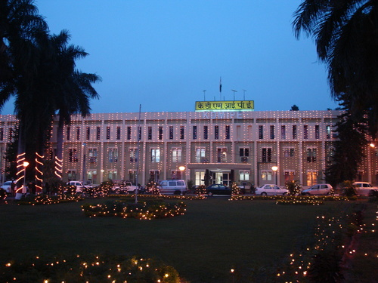

**IT division in KDMIPE provides repair and maintain ace services to various equipment’s installed in different labs of KDIMPE through in-house expertise.**

**It also provides Repair and maintenance services through OEM/OES throughout sourcing.**

**It also caters IT services to KDIMPE users for complete IT infrastructure such as repair and maintenance of PC’s, Printer’s and LAN systems.**

**IT provides various communication services such as EPABX connections, audio visual services in various auditoriums of KDIMPE.**

**SUMMER PROJECT**

**VEHICLE CONTROL SYSTEM**

**BASED ON**

**BLOOD ALCOHOL CONCENTRATION**

**LEVELS**

**Theme**

The main purpose behind this project is “Drunk driving detection”. Now days, many accidents are happening because of the alcohol consumption of the driver or the person who is driving the vehicle. Thus drunk driving is a major reason of accidents in almost all countries all over the world.

This is killing not only the driver but also the co-passengers travelling on the road at the same time. It is impossible for police to check each and every vehicle

for drunken drivers, so an effective system which automatically prevents drunken driving is needed. This system can be integrated with the ignition system thus allowing only sober people to handle the car. Alcohol Detector in Car project is designed for the safety of the people seating inside the car. This project should be fitted / installed inside the vehicle.

**HISTORY**

According to a survey done by W.H.O Almost every 90 seconds, a person is injured in a drunken driving crash. One in three people will be involved in an alcohol-related crash in their lifetime. In America on average, nearly 12,000 people die every year in DUI-related accidents. 900,000 are arrested each year for DUI/DWI and a full 1/3 of those are repeat offenders. Because of Drunk and Drive the people are highly injured or sometimes dead. Let’s look at some facts

* Approximately 10% of traffic deaths are caused by drunk drivers.
* In the early 1980′s alcohol-related fatalities in the states were about as high as 26,000 deaths a year.
* In the past recent years, there has been an average of 13,000 deaths a year due to drunk driving.
* Young men are reported to have a much higher rate of drunk driving than women.
* An average drunk driver has driven drunk 87 times before first arrest.
* Alcohol-related deaths in 2008 are reported have served as around 35% of all traffic-related deaths in America
* Young drivers are at the highest risk for drunk driving accidents.
* 50 to 75% of convicted drunk drivers continue to drive on a suspended license.
* One person is killed every half-hour due to drunk driving
* each year approximately 16,000 are killed in alcohol related crashes
* Alcohol is a factor in almost half of all traffic fatalities
* Every other minute a person is seriously injured in an alcohol related crash

With India reporting as many as 1.34 lakh fatalities in road accidents every year, a vast 70 per cent of them being due to drunken driving. About 56 accidents and nearly 14 deaths occur on our roads per hour. It is significant to note that the number of persons killed per lakh of population has risen to about 11 and simultaneously India also records the highest per capita consumption of alcohol in South East Asia.

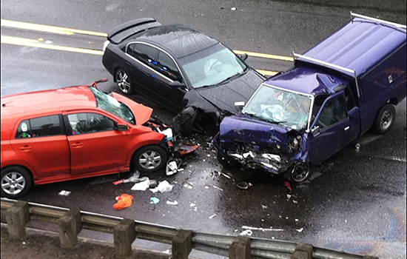

**Description & Working**

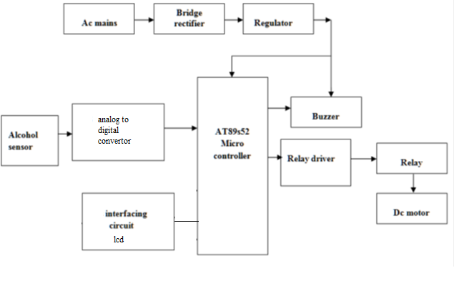

This system provides a unique method to curb drunken people. The system has an alcohol sensor embedded on the steering of the car. Whenever the driver starts ignition, the sensor measures the content of the alcohol in his breath and automatically switches off the car if he is drunken. In this system the sensor delivers a current with a linear relationship to the alcohol molecules from zero to very high concentration. The output of the sensor is fed to the microcontroller for comparison. If the measured value reaches the threshold, relay cut off automatically and the buzzer produces sound and the car is stopped.

This type of sensor circuit can be used as a breathalyzer to check a person's blood alcohol level. Just as we exhale carbon dioxide when we breathe out, we also will breathe out some alcohol if we have alcohol in our blood. Any device can measure this alcohol content. For different countries, the level of alcohol in the blood that defines a person as over the limit for driving varies. The range ranges from 0.01 to 0.10. Most countries have a limit of about 0.05. For example, Greece, Greenland, and Iceland all have limits of 0.05. Canada has a higher limit set at 0.08. In the United States, it is also 0.08.

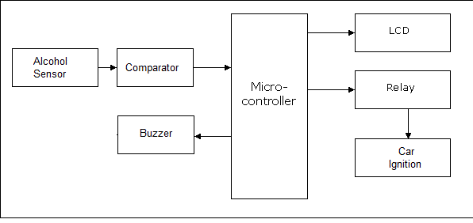

If the person inside car has consumed alcohol then it is detected by the sensor. Sensor gives this signal to a comparator IC. The output of comparator is connected to the microcontroller. Microcontroller is the heart of this project. It is the CPU of the complete circuit. Microcontroller gives high pulse to the buzzer circuit and the buzzer is turned on. At the same time a relay is turned off. Due to this the ignition of the car is deactivated. The system designed is for the sensing of alcohol using MQ3 alcohol sensor which in turn activates the rectifier that initiates the relay through which a signal is transmitted in form of a delay. This delay will activates/deactivates the DC motor. (In general a motor is the basic component in the engine vehicle system).

**Use-**

1) “Alcohol Detector project” can be used in the various vehicles for detecting whether the driver has consumed alcohol or not.

2) This project can also be used in various companies or organization

to detect alcohol consumption of employees .

3) “Alcohol Detection System in Cars” provides an automatic safety system for cars and other vehicles as well.

Working-



The main unit of this project is an “Alcohol sensor”. If the person inside car has consumed alcohol then it is detected by the sensor. Sensor gives this signal to a comparator IC. The output of comparator is connected to the microcontroller. Microcontroller is the heart of this project. It is the CPU of the complete circuit. Microcontroller gives high pulse to the buzzer circuit and the buzzer is turned on. At the same time a relay or a TRIAC is turned off. Due to this the ignition of the car is deactivated. We can implement GSM technology to inform the relatives or owners of the vehicle about the alcohol consumption. We can implement GPS technology to find out the location of the vehicle.

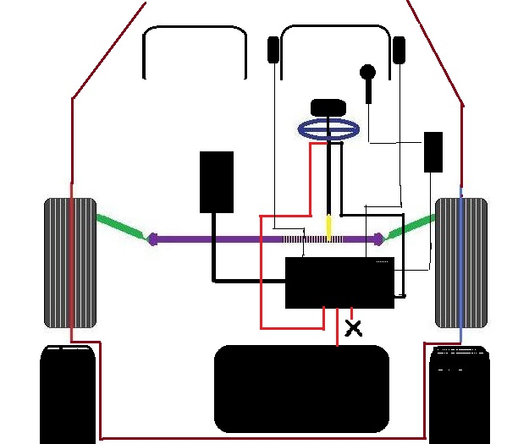

SCHEMATIC DEMONSTRATION

How a Car Starts

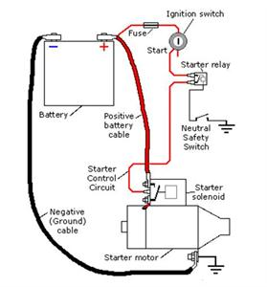

To make an [engine](http://www.howacarworks.com/basics/the-engine) start it must be turned at some speed, so that it sucks fuel and air into the cylinders, and compresses it.

The powerful [electric starter](http://www.howacarworks.com/basics/how-the-starting-system-works) motor does the turning. Its shaft carries a small pinion (gear wheel) which engages with a large gear ring around the rim of the engine flywheel.

In a front-engine layout, the starter is mounted low down near the back of the engine.

The starter needs a heavy electric current, which it draws through thick wires from the [battery](http://www.howacarworks.com/basics/how-the-charging-system-works). No ordinary hand-operated switch could switch it on: it needs a large switch to handle the high current.

The switch has to be turned on and off very quickly to avoid dangerous, damaging sparking. So a solenoid is used - an arrangement where a small switch turns on an electromagnet to complete the circuit.

The starter switch is usually worked by the ignition key. Turn the key beyond the 'ignition on' position to feed current to the solenoid.

The ignition switch has a return spring, so that as soon as you release the key it springs back and turns the starter switch off.

When the switch feeds current to the solenoid, the electromagnet attracts an iron rod.

The movement of the rod closes two heavy contacts, completing the circuit from the battery to the starter.

The rod also has a return spring -when the ignition switch stops feeding current to the solenoid, the contacts open and the [starter motor](http://www.howacarworks.com/basics/how-the-starting-system-works) stops.



The engine is cranked and hence started by supplying battery power to it for some time.. When output from logic circuit is logic1, the microprocessor’s program is interrupted and stopped so that switch remains closed and engine cranks. On the other hand when output is logic0 the program continues and opens circuit after 10 secs thus stopping engine ignition.

How to Convert  
The MQ3 sensor produces an analog output signal between 0 and 1023.  
 BAC is expressed as the weight of ethanol, measured in grams per 210 liters of breath.  
To convert mg/L to BAC, multiply by 210 and divide by 1000, or in other words, multiply by 0.21.  
  
 For example, if the analog output from our MQ3 is reading 400, we divide 400 by 1023 (the highest analog value) in order to get the ratio or percentage of alcohol on the breath.  
Then we determine that 0.4 or 40% alcohol on the breath will yield 0.4 * 0.21 = 0.084, which is slightly more than the legal limit in in most states of 0.08

**Circuit**

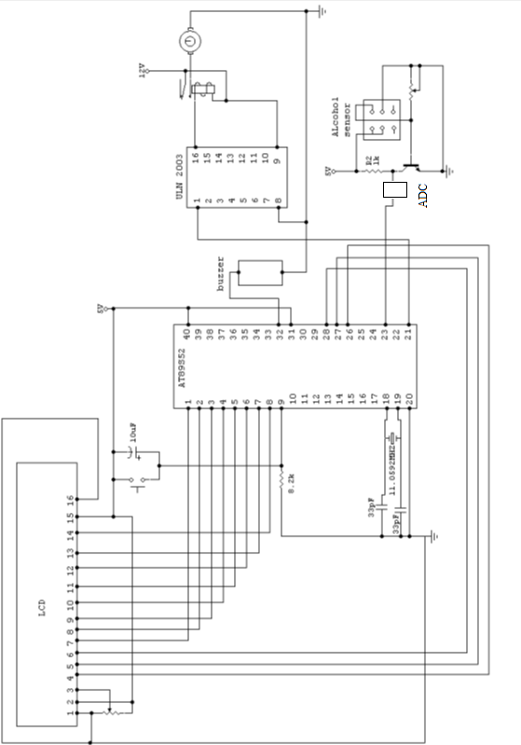

Components

Hardware

* MQ-3 Alcohol Sensor

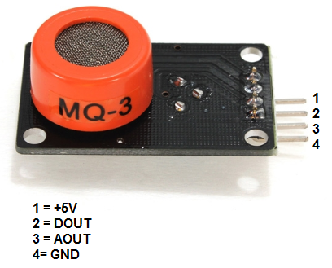

This is an alcohol sensor, which detects ethanol in the air. It is one of the straight forward gas sensors so it works almost the same way with other gas sensors. Typically, it is used as part of the breathalyzers or breath testers for the detection of ethanol in human breath.

Basically it has 6 pins, the cover and the body. Even though it has 6 pins, we can use only 4 of them. 2 of them are for heating system and other 2 are for connecting power and ground. A little tube is placed inside the sensor. This tube is a heating system that is made of aluminum oxide and tin

Dioxide and inside of it there are heater coils, which practically produce the heat. Two pins are connected to the heater coils and others are connected to the Tube .

The core system is the cube. Basically, it is an Alumina tube cover by SnO2, which is tin dioxide. And between them there is an Aurum electrode. Basically, the alumina tube and the coils are the heating system.

If the coil is heated up, SnO2 ceramics will become the semi - conductor, so there are more movable electrons, which means that it is ready to make more current flow. Then, when the alcohol molecules in the air meet the electrode that is between alumina and tin dioxide, ethanol burns into acetic acid then more current is produced. So the more alcohol molecules there are the more current we will get. Because of this current change, we get the

different values from the sensor.

Character Configuration -

* Good sensitivity to alcohol gas

* Long life and low cost

* Simple drive circuit Application

* Vehicle alcohol detector

* Portable alcohol detector

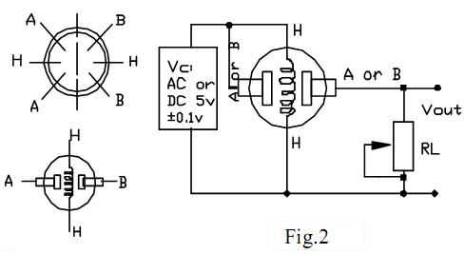

* Display Unit

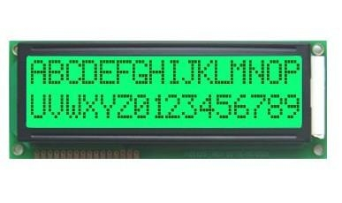

LCD display is used for displaying the message that sent from the remote location. The LCD module is a dot- matrix liquid crystal display

that displays alphanumeric, kana (Japanese characters) and symbols. The CMOS technology makes the device ideal for applications in hand-held

portable and other battery-powered instruments with low power applications. Most LCDs with 1 controller has 14 Pins and LCDs with 2 controller

has 16 Pins (two pins are extra in both for backlight LED connections).

Above is the quite simple schematic. It consists of 16 pins (8 data lines, 3 control lines, 2 power lines, 1 contrast line and 2 pins for back light

LED connection). Data line and control line are connected to the microcontroller.

The LCD panel's Enable and Register Select is connected to the

Control Port. The Control Port is an open collector /

open drain output. When connecting LCD module to a parallel I/O device, the burden of ensuring proper operation falls on the software. While most

Parallel Ports have internal pull-upresistors, there is

a few which don't. Therefore by incorporating the two 10K external pull up resistors, the circuit is more portable for a wider range of computers, some

of which may have no internal pull up resistors. At the interface of LCD module, there are three power supply terminals- Vdd, GND, Vo. The

LCD is driven by a voltage which is determined by Vdd-Vo.

**Component Used**-The **Hitachi** HD44780 2x16 **LCD** controller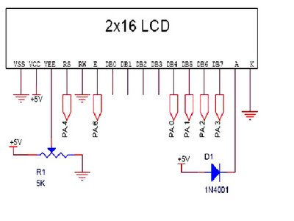

The data bus lines are DB7-DB0.When the enable signal is at the low level, this data bus terminals will remain in a high impedance state.

When the data bus is open it produces a high output

voltage. When the busy flag is at a high level, it indicates that the controller is in the internal operation mode and the next instruction will not be

accepted. The next instruction must be written after the busy flag goes low. The delay should be suitable for most machines.

* DC MOTOR:

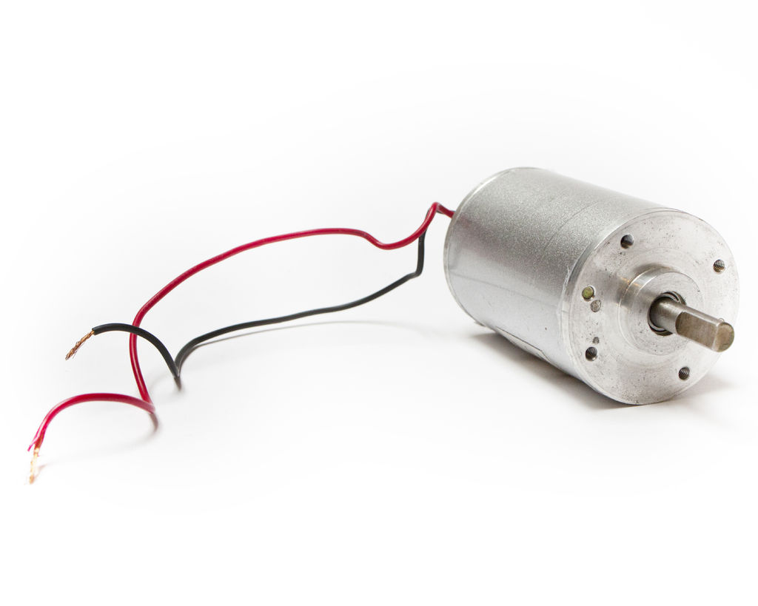

A DC motor is a mechanically commutated electric motor powered from direct current (DC). The stator is stationary in space by definition and therefore its current. The current in the rotor is switched by the commutator to also be stationary in space. This is how the relative angle between the stator and rotor magnetic flux is maintained near 90 degrees, which generates the maximum torque.

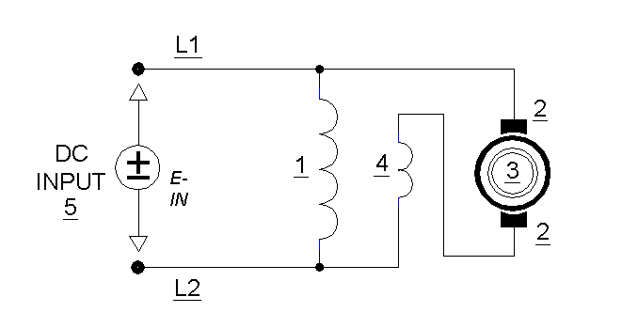

DC motors have a rotating armature winding (winding in which a voltage is induced) but non-rotating armature magnetic field and a static field winding (winding that produce the main magnetic flux) or permanent magnet. Different connections of the field and armature winding provide different inherent speed/torque regulation characteristics. The speed of a DC motor can be controlled by changing the voltage applied to the armature or by changing the field current. The introduction of variable resistance in the armature circuit or field circuit allowed speed control. Modern DC motors are often controlled by power electronics systems called DC drives.

The introduction of DC motors to run machinery eliminated the need for local steam or internal combustion engines, and line shaft drive systems. DC motors can operate directly from rechargeable batteries, providing the motive power for the first electric vehicles. Today DC motors are still found in applications as small as toys and disk drives, or in large sizes to operate steel rolling mills and paper machines.

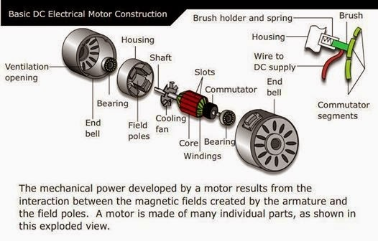

* Analog to Digital Converter:

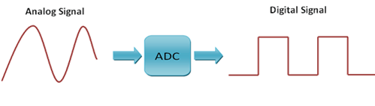

We Know That System Understands Only Boolean Data and the Output of the regulator is Analog Value. That Is Why ADC Convertor Is Used .the main functionality of the ADC converter is to Covert the Analog Signal into Digital data viz, machine level language.

**Component Used-**ADC 8084

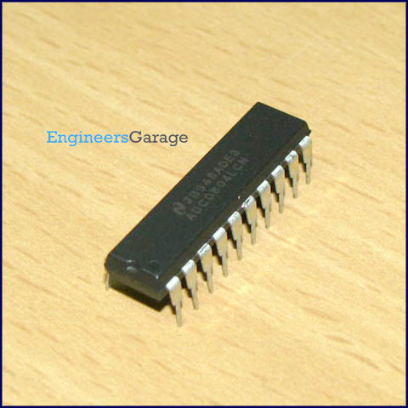

Operation

An analog-to-digital converter (abbreviated ADC, A/D or A to D) is a device that converts a continuous physical quantity (usually voltage) to a digital number that represents the quantity's amplitude.

The conversion involves quantization of the input, so it necessarily introduces a small amount of error. Instead of doing a single conversion, an ADC often performs the conversions ("samples" the input) periodically. The result is a sequence of digital values that have converted a continuous-time and continuous-amplitude analog signal to a discrete-time and discrete-amplitude digital signal.

An ADC may also provide an isolated measurement such as an electronic device that converts an input analog voltage or current to a digital number proportional to the magnitude of the voltage or current. However, some non-electronic or only partially electronic devices, such as rotary encoders, can also be considered ADCs. The digital output may use different coding schemes. Typically the digital output will be a two's complement binary number that is proportional to the input, but there are other possibilities. An encoder, for example, might output a Gray code.

* Relays

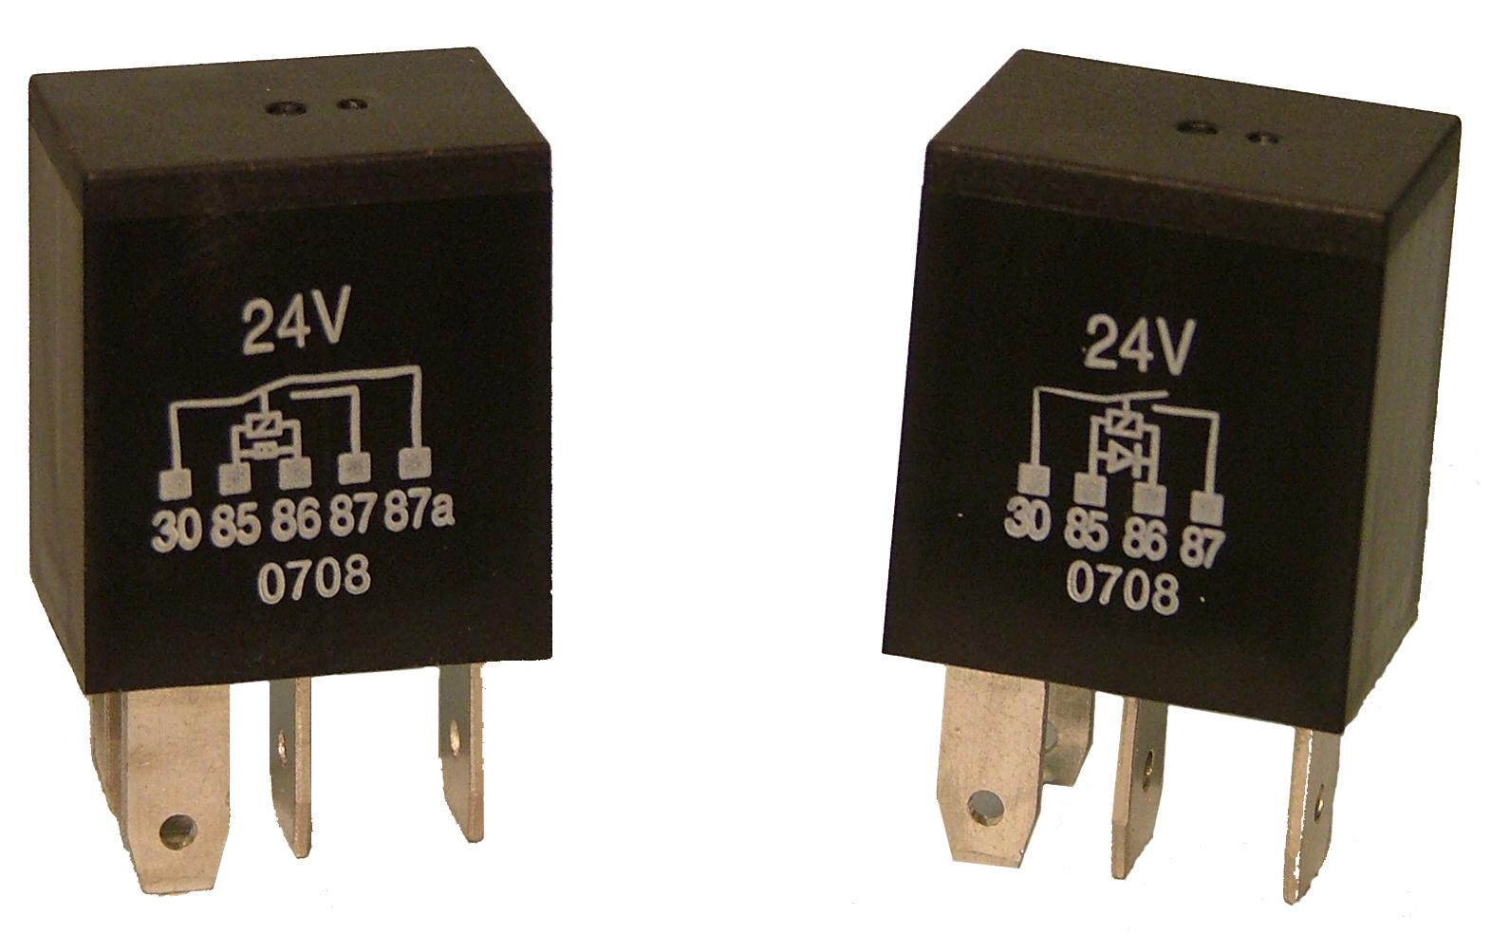

A relay is an [electrically](https://en.wikipedia.org/wiki/Electric) operated [switch](https://en.wikipedia.org/wiki/Switch). Many relays use an [electromagnet](https://en.wikipedia.org/wiki/Electromagnet) to mechanically operate a switch, but other operating principles are also used, such as [solid-state relays](https://en.wikipedia.org/wiki/Solid-state_relay). Relays are used where it is necessary to control a circuit by a low-power signal (with complete electrical isolation between control and controlled circuits), or where several circuits must be controlled by one signal. The first relays were used in long distance [telegraph](https://en.wikipedia.org/wiki/Electrical_telegraph) circuits as amplifiers: they repeated the signal coming in from one circuit and re-transmitted it on another circuit. Relays were used extensively in telephone exchanges and early computers to perform logical operations.

**Component Used-ULN 2003 Relay Driver**

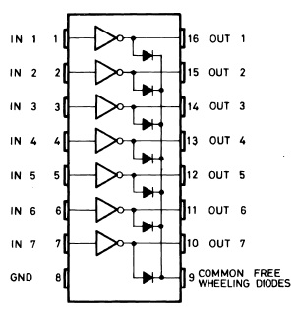

* TRIAC

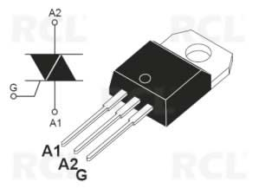

* The TRIAC is a three terminal semiconductor device for controlling current. It gains its name from the term **TRI**ode for **A**lternating **C**urrent.
* It is effectively a development of the SCR or thyristor, but unlike the Thyristor which is only able to conduct in one direction, the TRIAC is a bidirectional device.

The TRIAC is a component that is effectively based on the thyristor. It provides AC switching for electrical systems. Like the thyristor, the TRIACs are used in many electrical switching applications. They find particular use for circuits in light dimmers, etc., where they enable both halves of the AC cycle to be used. This makes them more efficient in terms of the usage of the power available. While it is possible to use two thyristors back to back, this is not always cost effective for low cost and relatively low power applications.

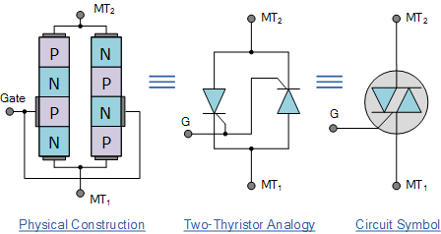

* **Power supply and voltage regulator**

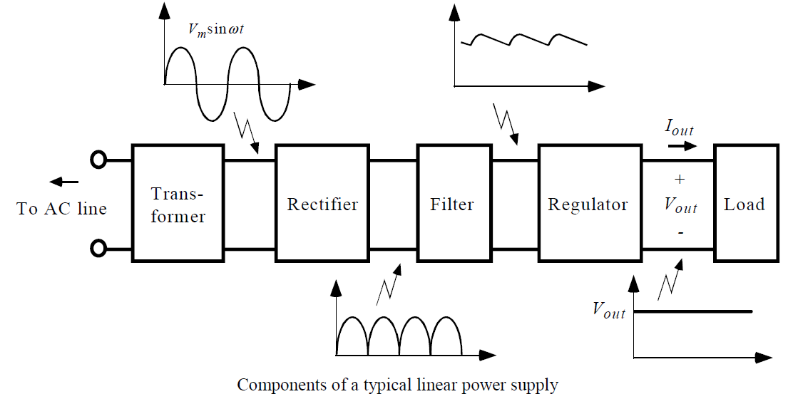

.It mainly consists of a voltage regulator (here it is 7805). The voltage regulator plays an important role in a power supply unit. Output of the

power supply unit is always dc which is given to the controller.

Voltage regulator is designed to automatically maintain a constant voltage level. Thus the voltage regulator regulates the voltage by 1V and constantly supplies the supply Voltage of 5V to the microcontroller at any instant of time.

**Component Used**-LM317, LM7805

Regulator Specification’s:

Vout range: 1.25 V – 37 V

Vin – Vout difference: 3 V – 40 V

Operation ambient temperature: 0℃ – 125℃

Output IMAX: less than 1.5 A (assuming factory-suggested heat sinking) Minimum Load Current max: 10 mA

The LM317 is a linear voltage regulator used in DC to DC converter applications. The overall function of

the LM317 is similar to that of the LM78xx series regulators. Whereas the 78xx series of regulators have fixed output voltages (ex. 7805 has 5V output), the LM317 can be adjusted to any voltage (within its limits).

The primary purpose of the regulator is to aid the rectifier and filter circuit in providing a constant dc voltage to the device. Power supplies without regulators have an inherent problem of changing of dc voltage values due to variations in the load or due to fluctuations in the input voltage. With regulator connected to the dc output, the voltage can be maintained with a close tolerant region of desired output.

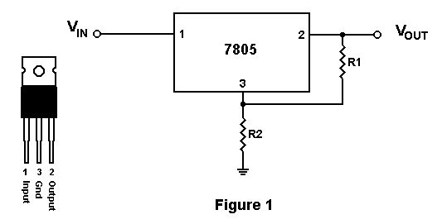

* Buzzer

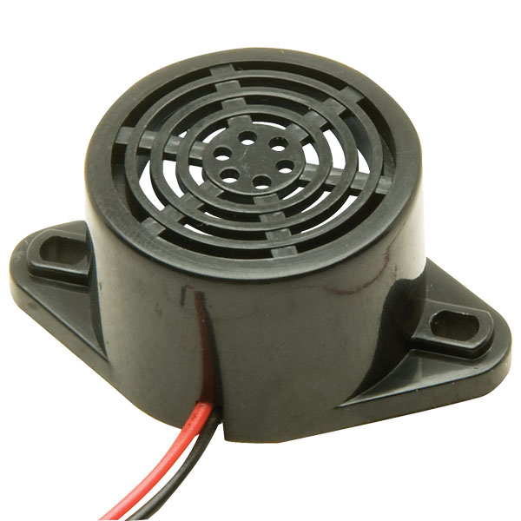

A buzzer is a mechanical, electromechanical, magnetic, electromagnetic, electro-acoustic or piezoelectric audio signalling device. A piezo electric buzzer can be driven by an oscillating electronic circuit or other audio signal source. A click, beep or ring can indicate that a button has been pressed.

**Component Used**-DC 3-24 V Industrial Buzzer

There are several different kinds of buzzers. Many of the most common types categorized by Type, Sound Level, Frequency, Rated Voltage, Dimension and Packaging Type.

The most common sizes for Sound Level are 80 dB, 85 dB, 90 dB and 95 dB. There are also buzzers with Sound Level up to 105 dB. There are several types available including Electro-Acoustic, Electromagnetic, Electromechanic, Magnetic and Piezo, among others.

* MICRO CONTROLLER UNIT

Why Microcontrollers

Microcontroller is an IC chip that takes input process data according to program written in its memory and gives output as control signal for controlling other machines and devices.

[How Microcontroller Works?](http://www.wikiforu.com/2012/10/what-is-microcontroller-how-it-works.html)  
  
            Microcontroller is used to control the operation of various machines and devices according to the program or given instructions in the memory or ROM of the Microcontroller. The program that is needed for proper working of Microcontroller is called Firmware and is written in ROM (Read Only Memory). ROM is a non-volatile memory that is its contents are permanent. Some latest ROMs can be Re-Programmed, but mostly it doesn't requires.

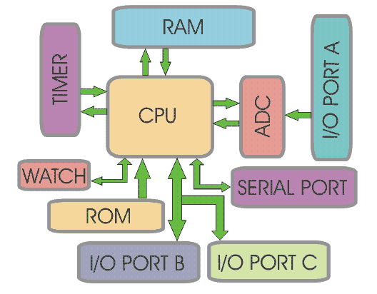

Advantages of Microcontroller:

Microcontroller's use increased rapidly. Now these are used in almost every electronic equipment like Washing Machines, Mobile Phones and Microwave Oven. Following are the most important facts about Microcontrollers, which causes rapid growth of their use:  
Microcontrollers are cheap and very small in size, therefore they can be embedded on any device.

* Programming of Microcontrollers is simple to learn. It’s not much complicated.
* We can use simulators on Computers to see the practical results of our program. Thus we can work on a Embedded project without even buying the required Components and Chips. Thus we can virtually see the working of our project or program.
* Microcontrollers act as a microcomputer without any digital parts.
* As the higher integration inside microcontroller reduce cost and size of the system.
* Most of the pins are programmable by the user for performing different functions.
* Easily interface additional RAM, ROM, I/O ports.

Applications of Microcontrollers:

Microcontrollers are mostly used in following electronic equipments :

* Mobile Phones
* Auto Mobiles
* CD/DVD Players
* Washing Machines
* Cameras
* In Computers-> Modems and Keyboard Controllers
* Security Alarms
* Electronic Measurement Instruments.
* Microwave Oven.

Introduction To 8051 Microcontroller-

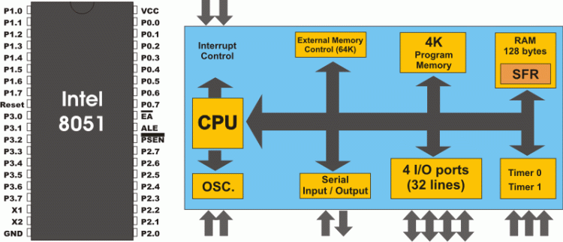

Intel designed Micro controller 8051 in 1980. It was an 8 bit Micro controller. It includes some standard on chip peripherals, timers, counters and UART's (Universal Asynchronous Receiver Transmitter).   
This Micro controller has 4 Kilo bytes on chip ROM that is program memory and 128 bytes of data memory. It is most popular Micro controller used in Embedded Systems.

Following are the main features of Micro controller 8051 which makes it most efficient Microcontroller chip:

* It Includes Boolean Processing Engine. Thus internal registers and RAM can carry Boolean logic operations directly and efficiently.
* It gives us many functions in a single chip. (For example: CPU,RAM,ROM,I/O, Interrupt, Timer etc)
* It have 8 bit Data bus.
* It have 8 bit Stack Pointer.
* It have 16 bit Program Counter.
* It have 16 bit address bus which can access almost 65,536 memory locations.
* Data memory or RAM of 128 bytes.(On-Chip).
* Program Memory or ROM of 4 KB.(On Chip).
* Bi-Directional I/O port of 4 bytes.
* It has 4 separate Register Sets.
* Serial Port or UART.
* It features Power Saving Mode which saves power.
* Two Timers/Counters each of 16 bit.
* Internal and External Interrupt Sources.
* 2 level interrupt priority.

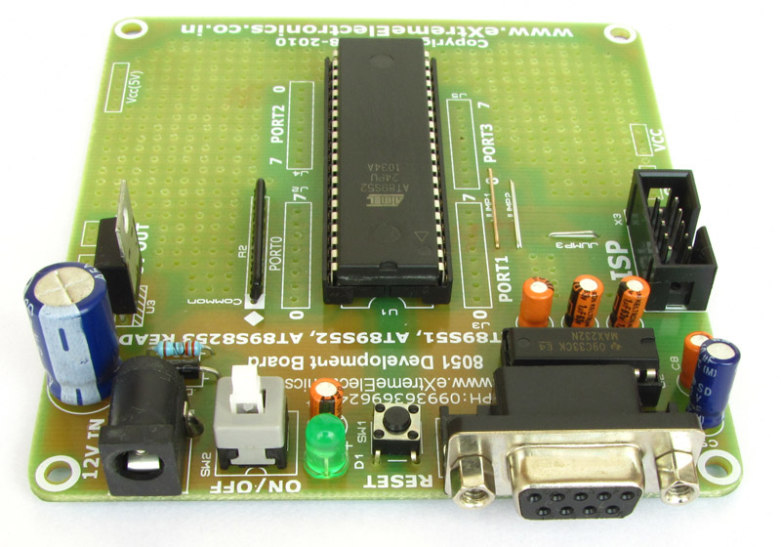

Micro Controller unit mainly comprises of 3 Parts ADC Converter, 8051microcontroller and input/output devices

A Microcontroller is an economical computer-on-a-chip built for dealing with specific tasks, such as displaying or receiving information through LEDs or remote controlled devices. In our project 8051 μ controller is used to compare the ADC output with the pre-defined reference voltage If it matches then μ controller will give command to the motor to work .

The Atmel versions of MCS51 supporting on-chip precision analog comparator are 89C2051 and 89C1051. The 8051 is designed as a strict Harvard architecture. The 8051 can only execute code fetched from program memory. The 8051 does not have any instruction to write to program memory. Most 8051 systems respect this distinction, and so are unable to download and directly execute new programs. The strict Harvard architecture has the advantage of making such systems immune to most forms of malware. Some 8051 systems have (or can be modified to have) some "dual-mapped" RAM, making them act somewhat more like Princeton architecture. This (partial) Princeton architecture has the advantage of making it possible for a Forth boot loader running on the 8051 to write new native code to RAM and then execute it, leading to faster incremental and interactive programming cycles than strict Harvard systems.

The MCS-51 has four distinct types of memory – internal RAM, special function registers, program memory, and external data memory.

Special function registers (SFR) are located in the same address space as IRAM, at addresses 0x80 to 0xFF, and are accessed directly using the same instructions as for the lower half of IRAM. They cannot be accessed indirectly via @R0 or @R1. 16 of the SFRs are also bit-addressable.

There are various high-level programming language compilers for the 8051. Several C compilers are available for the 8051, most of which allow the programmer to specify where each variable should be stored in its six types of memory, and provide access to 8051 specific hardware features such as the multiple register banks and bit manipulation instructions. There are many commercial C compilers. SDCC is a popular open source C compiler. Other high level languages such as C++, Forth, BASIC, Pascal/Object Pascal, PL/M and Modula-2 are available for the 8051, but they are less widely used[citation needed] than C and assembly.

**Component used-**

AT89S52

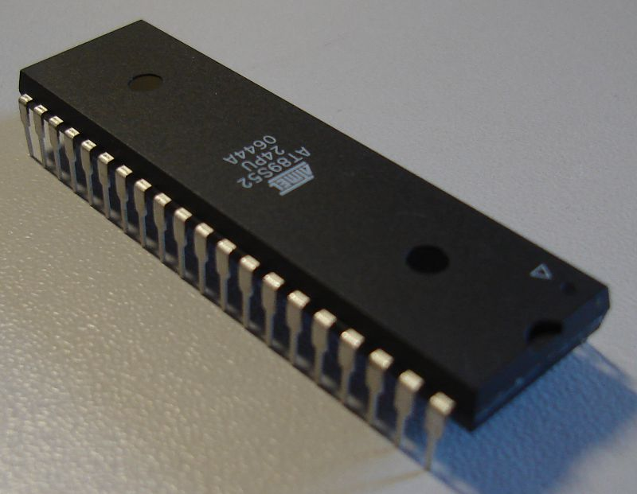

Low-power, high-performance CMOS 8-bit microcontroller with 8KB of ISP flash memory. The device uses Atmel high-density, nonvolatile memory technology and is compatible with the industry-standard 80C51 instruction set and pinout. On-chip flash allows the program memory to be reprogrammed in-system or by a conventional nonvolatile memory programmer. This powerful microcontroller is suitable for many embedded control applications.

* Key Parameters

Parameter: Value

Flash (Kbytes):8 Kbytes

Pin Count: 44

Max. Operating Freq. (MHz):24 MHz

CPU: 8051-12C

Max I/O Pins: 32

UART: 1

SRAM (Kbytes): 0.25

Operating Voltage (Vcc): 4.0 to 5.5

Timers: 3

ISP: SPI

VCC-PIN40

GROUND-PIN20

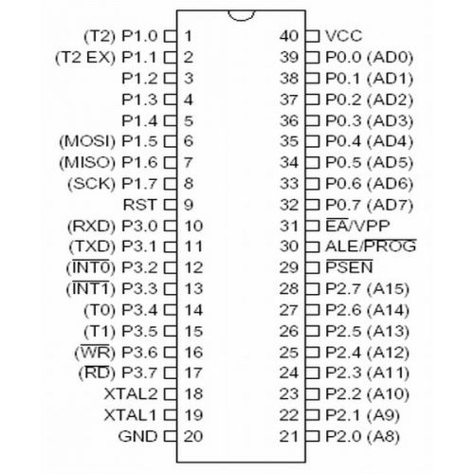

PIN CONFIGURATION-AT895S2

Software System-

Embedded Software deals with languages like ALP, C, VB,etc. Here we have used Embedded C Programming. Embedded C is set of a language extensions for c programming which introduces number of features not available in normal C. Its key characteristics are:

1) Simple to learn, understand, program and debug.

2) C Compilers are available to almost all embedded devices and there is a large pool of experienced C programmers.

3) Provides easy management of large embedded projects.

The use of C language to program microcontrollers is becoming too common. And most of the time it’s not easy to build an application in assembly which instead you can make easily in C. So it’s important that you know C language for microcontroller which is commonly known as Embedded C.



**Keil MicroVision** is free software which solves many of the pain points for an embedded program developer. This software is an integrated development environment (IDE), which integrated a text editor to write programs, a compiler and it will convert your source code to hex files too. **KEIL IDE** is basically an assembler and a compiler or whatever you name it. You can write either an Assembly or C language code and KEIL will take care of the rest for you. Furthermore, it supports many of the 8051 variants that we can face.

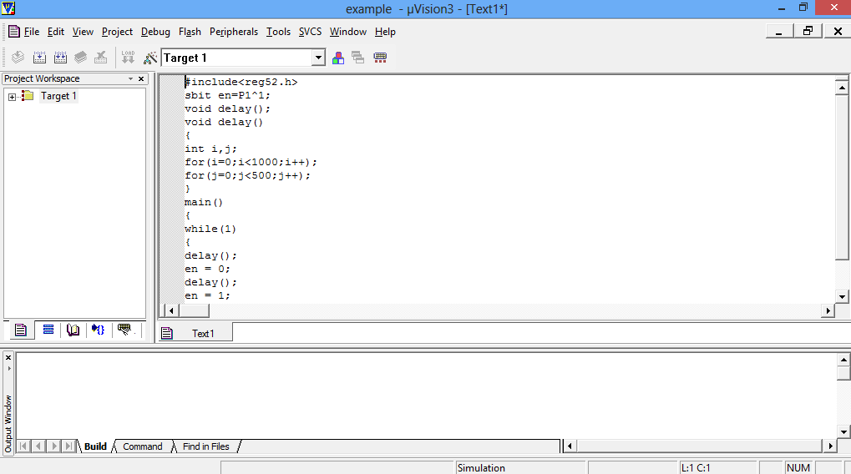

Interface Screen

The software code is as follows-

#INCLUDE<REG51.H>

#INCLUDE<INTRINS.H>

//#DEFINE LCD_PORT P1

#INCLUDE"LCD_BUSY.H"

#INCLUDE"ADC.H"

SBIT TRAIC1=P2^7;

SBIT DC12=P0^1;

VOID MAIN ()

{

LCD_INIT();

LCD_INIT();

MESSAGE(0X80,"ATMTIC GAS LEKGE");

MESSAGE(0XC0," DETECTION ");

DELAY(1000);

INIT(0X01);

WHILE(1)

{

MESSAGE(0X80,"TEMPERATURE");

Z=ADCDATA();

X=((Z/1023 ) * 0.21);

IF (X<0.08)

{

TRAIC1=1;

//DC12=0;

MESSAGE(0X80,"NO GAS DETECTED ");

}

IF(X>=0.08)

{

TRAIC1=0;

// DC12=1;

MESSAGE (0X80," GAS DETECTED ");

}

}

}

After debugging, the program is burned into the Microcontroller using prerequisite setting and configuration.

**Future Developments**

1) Detection using facial monitoring system using Image Processing.

2) The project can be extended to an improved version for preventing drunk drivers from getting on the road with new concept car filled with alcohol detection sensors.

3) These new sensors check a Person’s odours, sweat, and driver awareness to see if they are capable of driving their car. If they’re not quite sober, the car locks up the ignition system there by preventing the driver from getting on the road.

4) In addition to the breathalyzers, skin sensors can also be provided for more safety.

5) Micro vehicle black box is a developing concept for anti-theft security system. This works in integration with cell phones. It is compatible with all GSM and CDMA mobiles. This allows two way communications with car and drivers. Unauthorized entry into car detection, car location and immobilization of car

is done with this technology.

6) We can implement GSM technology to inform the relatives or owners of the vehicle about the alcohol consumption.

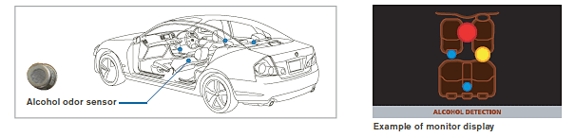

Conclusion

Our project Alcohol Detection System was implemented successfully. This device provides much advanced facilities in now a days life as it can be easily implemented in vehicles. Thus we can reduce alcohol related road accidents and hence these kinds of detectors have a great relevance. It can also be used in schools, colleges, offices and some public places such as hospitals, libraries etc. Through this project we present hardware programming of microcontroller to facilitate as Alcohol sensor. Tests found that this system is highly effective and it’s efficient in testing the alcohol percentage of the human beings and if it crossed the threshold value the dc motor will stop working. It’s practically implemented in some cars ex: Nissan N90.

We hope and assure that the response for the project we have designed will be great. People will have a greater benefit and this module will save the lives of many people. The success of our innovation will sustain for a long period of time and this will be a good use to the public.

**General Training-**



* **Introduction to ONGC**
* **Basic Electronics**
* **AC-DC Circuits**
* **Transformers (Power)**
* **Rectifiers**
* **Diode-Series, Types and Physical Specifications**
* **Introduction to Chips**
* **Transistors-NPN,PNP (Series)**
* **Filters-PI,L-Shaped**
* **PCB & Circuit Boards**
* **Fuses and Metal Oxide Varisters**
* **Opto-couplers ,LED & Sensors**
* **TRIACS & SCR**
* **Introduction to Relays**
* **Introduction to Communication Concepts**
* **SAP & SCADA**
* **Exploration & Production In ONGC**
* **Soldering & Desoldering Guidelines**
* **Instrumentation and Control Systems in ONGC**
* **Cloud Computing**

**Laboratory Visits-**

1. Micro Biology Lab

BOD Incubators were demonstrated and the cooling and thermal processes being acted upon were explained.

2. Sedimentology Lab

Worked on a Scanning Electron Microscope with the capability of zooming levels up to 3 lakh times. The model Number was of JOIL.

3. Geochronology (GC) Lab

A Normal Ionization Mass Spectrometer was worked upon. The Machine contained a Turret Filament Tube and is used for Isotope Dating and each concentration of Isotope block is checked and analyzed. A Faraday Multiplier is also used.

4. HQ. Tel Bhavan Museum

The IPE is rechristened KDIMPE by Indra Gandhi in 1981. Prior to that, a 5 year plan was initialized by Sir Nikolai Alkendrovich Flenn for Oil Exploration. Today it stands at a greater emphasis on Research, Development & Exploration and Production.

5. Stable Isotope Lab

A Ratio Mass Spectrometer for Genetic characterization of Molecular Mass was demonstrated. For liquid Analysis, A Gas Chromatograph which does the similar isotopic analysis was also explained. Importance of Air compressor and Vacuum tubes in the Circuits is also highlighted.

6. Diffraction and Microscopy Lab

An X-Ray diffractometer was explained and worked upon.

7. ONGC Satellite Centre

Networking Concepts like MF TDMA, VOIP, Simplex, Duplex and casting methods were explained. Role of Geo stationery satellites (GSAT 10) were demonstrated. Resulting Conversion rate and capacity for the transmission was given.

8. Computer Centre

High End IBM servers with OMEGA Software package were introduced and the role of Robotic Tape Library and Cluster based Data processing principles were explained.

9. Green Building

The ONGC Green hills here have a total built up area of 14,600 square metre and it is spread over five floors with the capacity to accommodate 620 persons. It can conserve water upto 30 per cent through use of onsite sewage plant and low flow sanitary sitting.

10. IDT

The Institute of Drilling Technology (IDT) was set up in 1978 at Dehradun. Institute of Drilling Technology (IDT) provides its techno-economic expertise & solutions to various field problems faced by various services of ONGC with the ultimate objective to promote cost effective E&P activities of the company.

Bibliography

* Dr. Charles Kim, Embedded computing with pic 16F877A
* Martin Jawitz, Printed circuit board material hand book
* [www.alldatasheets.com](http://www.alldatasheets.com)
* Understanding automotive electronics- William Ribbens 6th edition.
* http://www.telit.com/en/products.php?p_id=3&p_ac=show&p=7.
* http://www.**telit**.com/module/infopool/download.php?id=165
* http://www.meas-spec.com/vibration-sensors.aspx.
* http://www.hansfordsensors.com/
* <http://www.bosch.com.au/content/language1/downloads/sensors.pdf>
* Single walls carbon Nano tube networks for ethanol vapor sensing applications-ilya v. Anoshkin
* CHEMICAL SENSORS. VOLUME 6: CHEMICAL SENSORS APPLICATIONS
* The 8051 microcontroller-keynath j ayala
* 8051MicrocontrollerInternals, Instructions, Programming and Interfacing by Subrata Ghoshal
* The 8051 Microcontroller and Embedded Systems using Assembly and C -by Mohammad Ali Mazidi